**Online Activity No. 8 and 9: Applying the User-Centered System Design Process**

**Chapter I. Introduction**

**Background of the study**

In recent years, badminton has experienced significant growth worldwide, with more enthusiasts participating in recreational play and competitive events. Despite this surge in interest, the existing market for purchasing badminton equipment, gear, and apparel often lacks a cohesive and specialized platform tailored to the needs of badminton players and organizers. Traditional retail channels and general ecommerce platforms may offer limited selections and insufficient information specific to badminton requirements, leading to challenges in finding suitable products and efficiently organizing events.

This app aims to centralize a wide range of badminton products from various brands and manufacturers into a single, accessible platform. By providing comprehensive product descriptions, user reviews, and comparison tools, the app will empower badminton enthusiasts to make informed purchasing decisions conveniently from their smartphones or tablets. Moreover, the app will streamline procurement processes for event organizers through features such as bulk purchasing options, customized orders, and reliable delivery services, thereby enhancing the efficiency of event planning and ensuring high-quality equipment for tournaments and competitions.

For retail partners and manufacturers specializing in badminton, the app represents an opportunity to expand their market reach and engage directly with a targeted audience of badminton players and fans. By establishing a direct digital connection, these stakeholders can optimize sales strategies and capitalize on the growing demand for specialized badminton products. Additionally, the app will serve as a valuable resource for coaches and instructors by offering access to specialized training equipment and resources tailored to skill development and performance enhancement. By integrating instructional content and product recommendations, the app aims to support coaches in improving player capabilities and fostering growth within the badminton community.

**Statement of the problem**

1. *Limited Language Support*
   * The app does not support multiple languages, which significantly limits its usability for non-English speaking users. This restriction not only hampers the user experience for a substantial portion of potential customers but also reduces the app's global market reach. Non-English speakers may struggle to navigate the app, understand product descriptions, or complete transactions, leading to frustration and eventual abandonment of the platform. As a result, the app fails to tap into diverse markets, thereby missing out on potential revenue and customer base expansion.
2. *No Offline Mode*
   * The lack of an offline mode in the app poses a major inconvenience for users who do not have consistent internet access. Without the ability to browse products or access their favorites offline, users are restricted to using the app only when they have a reliable internet connection. This limitation can be particularly problematic for users in areas with poor connectivity or those who want to shop on the go without using mobile data. The absence of offline functionality can lead to a poor user experience, reducing overall engagement and customer satisfaction, and ultimately resulting in lower retention rates.
3. *Limited Product Availability:*
   * The app often faces issues with stock shortages and limited product availability. Users frequently encounter situations where items they are interested in are out of stock, leading to frustration and disappointment. This problem not only disrupts the shopping experience but also drives potential customers to competitor platforms where the desired products may be readily available. Consistent product shortages can damage the app's reputation, decrease user trust, and result in lost sales opportunities, making it crucial to address inventory management and product availability issues to maintain a competitive edge in the market.

**Assumption of the study**

1. *Multilingual Support Integration*
   * It is assumed that integrating multiple language options into the app will significantly enhance its accessibility and user experience for non-English speaking customers. By supporting a wider range of languages, the app will be able to reach a more diverse and global audience, thereby increasing its market potential and customer base. The proposed design improvements will include a comprehensive localization strategy that encompasses not just the translation of text, but also cultural nuances and regional preferences to ensure a seamless user experience across different languages.
2. *Offline Mode Implementation*
   * It is assumed that implementing an offline mode will improve the app's functionality and user satisfaction by allowing users to browse products and access their favorites without an active internet connection. This feature will be particularly beneficial for users in regions with unreliable internet connectivity and for those who prefer to shop without using mobile data. The offline mode will include the ability to cache product data and user favorites, ensuring a smooth and uninterrupted browsing experience. Enhancing the app with offline capabilities is expected to increase user engagement, retention, and overall satisfaction.
3. *Enhanced Inventory Management*
   * It is assumed that improving inventory management and ensuring better product availability will reduce user frustration and increase customer loyalty. By implementing a more robust and responsive inventory system, the app will be able to keep popular items in stock and provide accurate real-time updates on product availability. Additionally, features such as waitlists or notifications for back-in-stock items will be introduced to keep users informed and engaged. These enhancements are expected to result in higher user satisfaction, reduced cart abandonment, and increased sales, as customers will have a more reliable and positive shopping experience.

**Significance of the study**

1. *Badminton Enthusiasts*

* The app provides a centralized platform for purchasing Badminton equipment, gear, and apparel. Enthusiasts can easily access a wide range of products, compare prices, read reviews, and make informed purchasing decisions conveniently from their devices. This enhances their overall shopping experience, ensuring they find the right products tailored to their needs and preferences.

1. *Badminton Event Organizers*

* Facilitates easy sourcing and procurement of equipment and merchandise for events. The app offers bulk purchasing options, customized orders, and ensures timely delivery, thus simplifying logistics and enhancing event planning efficiency. Event organizers can rely on the app to streamline the procurement process, ensuring they have quality products on time for their tournaments and events.

1. *Retail Partners and Manufacturers*

* Enables direct access to a broader customer base. The app serves as a marketing platform, promoting products to a targeted audience of badminton enthusiasts, thereby increasing brand visibility and sales opportunities. Retail partners and manufacturers benefit from increased exposure and sales through a dedicated platform catering specifically to badminton players and fans.

1. *Coaches and Instructors*

* Offers access to specialized equipment and resources for training purposes. Coaches can recommend and source specific gear tailored to their training programs, fostering skill development and enhancing performance in Badminton activities. The app supports coaches in providing their students with the best tools and equipment to improve their skills and performance on the court.

1. *Badminton Federations and Associations*

* Supports community engagement and development initiatives. The app can feature educational resources, safety guidelines, and promote adherence to regulations set by federations, thereby advancing the sport responsibly. Federations and associations can leverage the app to disseminate important information, promote events, and engage with their community, ultimately fostering growth and sustainability in the sport.

1. *Investors and Stakeholders*

* Demonstrates market demand and potential profitability. The study highlights consumer preferences, market trends, and competitive analysis within the badminton ecommerce sector, aiding in strategic decision-making and investment opportunities. Investors can use the insights gained from the study to assess the viability of investing in the badminton ecommerce market, recognizing its growth potential and consumer demand.

**Chapter II. Research Design**

*User-Centered System Design Process*

This chapter outlines the design process model used by the group, detailing each stage of the user-centered system design process. The process includes the following stages:

1. **Task Analysis**

In this stage, the hierarchical task analysis of the proposed design is provided, both in textual form and as a figure. This analysis breaks down the tasks that users need to perform to achieve their goals within the app. The tasks are organized hierarchically to show the relationships between them and to identify the necessary steps for each task.

* + Login / Account Creation
  + Product Browsing
  + Product Purchase
  + Profile Setup

1. **Requirements Gathering**

This section discusses how the group gathered the necessary data for the proposal, employing various methods and relating them to their own experiences.

***Methods Used***

1. *Interview*

* Conducted interviews with badminton enthusiasts, event organizers, and retail partners to understand their needs and preferences.
* Questions focused on current challenges in purchasing badminton equipment and organizing events.

1. *Survey/Questionnaire*

* Distributed surveys to a broader audience to gather quantitative data on user preferences, common issues, and desired features in a badminton e-commerce app.

1. *Observation*

* Observed users interacting with existing e-commerce platforms to identify usability issues and areas for improvement.
* Analyzed user behavior to understand common pain points and preferences.

***Requirements Based on Perspectives***

1. *User Requirements*

* Multilingual support for non-English speakers
* Offline mode for users with inconsistent internet access
* Comprehensive product information and reviews

1. *Functional Requirements*

* Secure and reliable payment system
* Efficient inventory management
* User-friendly interface

1. *Data Requirements*

* User profiles and preferences
* Product details and stock levels
* Transaction records

1. *Environmental Requirements*

* Compatible with various devices (smartphones, tablets)
* Responsive design for different screen sizes

1. *Usability Requirements*

* Easy navigation and search functionality
* Clear and concise product descriptions
* Accessible interface for users of all skill levels

1. *Designers Requirements*

* Integration of user feedback for continuous improvement
* Adherence to best practices in UX/UI design

1. **Storyboarding and Prototyping**

The prototype of the interactive system -System input and output forms should be presented here and will be described on how it will function when the user utilizes it (this part will be presented as a user’s manual including the description and functions of the parts of the hardware/technology)

***Scenario 1***

Kyle, a student at MMCM, is passionate about badminton but struggles to find quality equipment in local stores, impacting his performance and enjoyment of the game. Despite his efforts, the gear available near campus is either overpriced or substandard, leaving him frustrated and demotivated. Without access to better equipment, Jason's progress stalls, and he worries he won't be able to compete effectively in the upcoming university tournament.

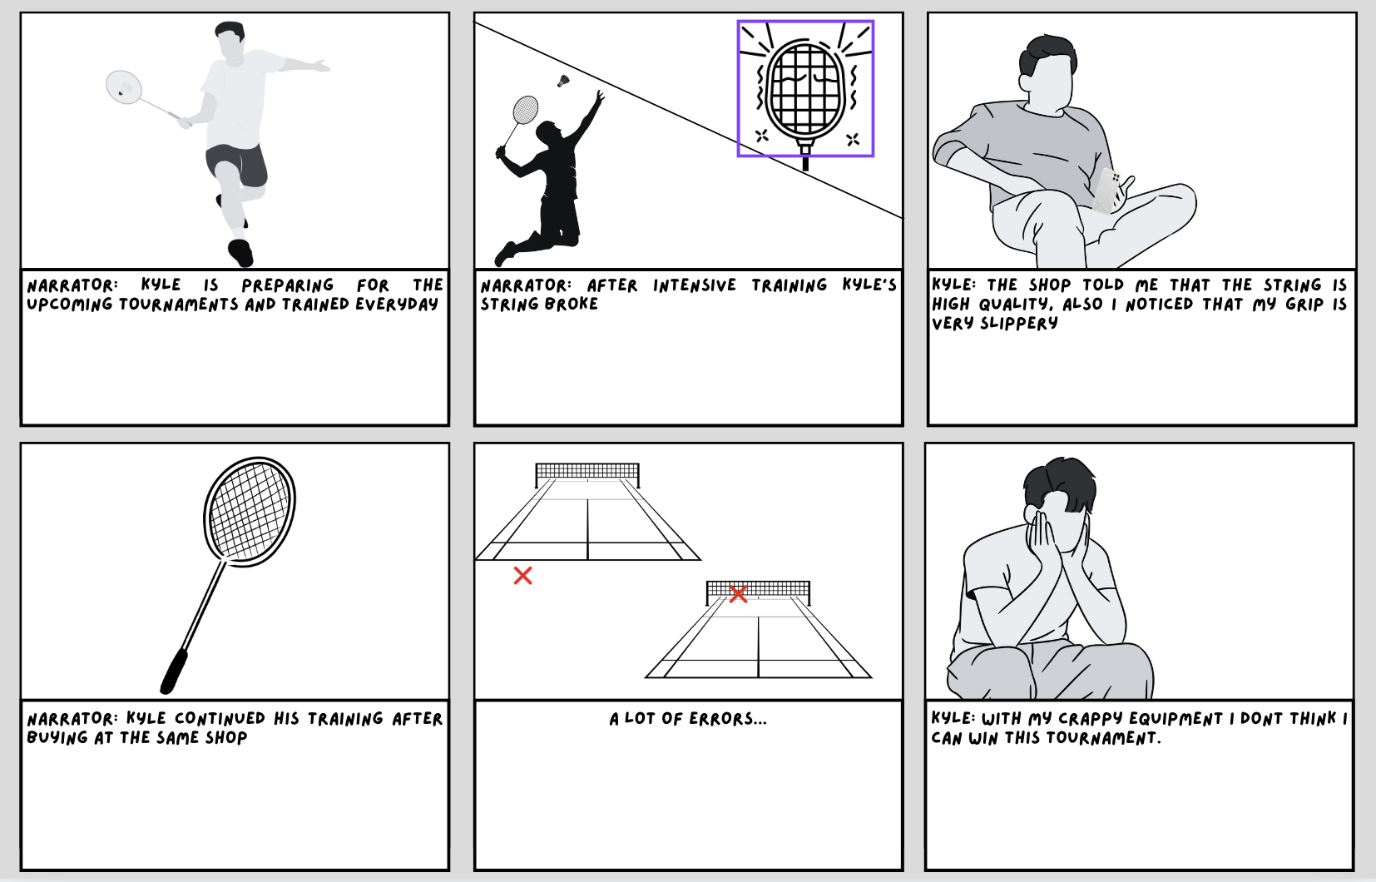

*Storyboard 1 - Kyle*

***Scenario 2***

Daniel, a dedicated badminton player, struggles to find high-quality, specialized gear at local stores and through e-commerce apps, which often lack detailed specifications like string tension and grip size. This leaves him frustrated and hinders his progress. Without a trustworthy source for quality equipment, Daniel's ability to compete at a higher level is compromised.

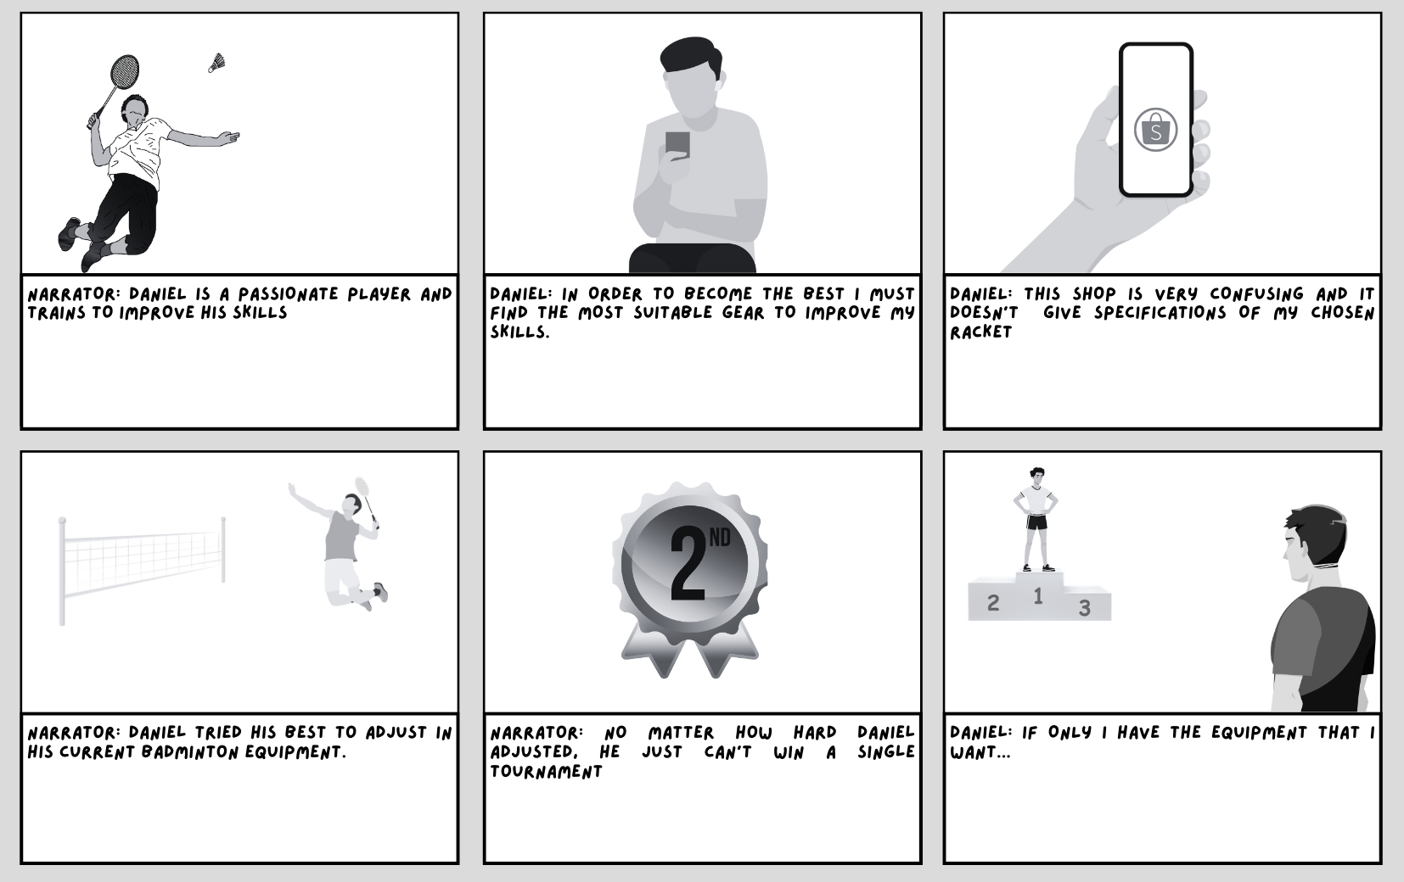

*Storyboard 2 - Daniel*

***Scenario 3***

Cecilia, a university badminton team captain, needs to outfit her entire team with new gear but is constrained by a limited budget. She finds that local stores offer either overpriced or low-quality equipment, making it difficult to provide her team with the necessary gear. Without affordable, high-quality options, Cecilia worries that her team will be underprepared for the upcoming season, potentially affecting their performance and morale.

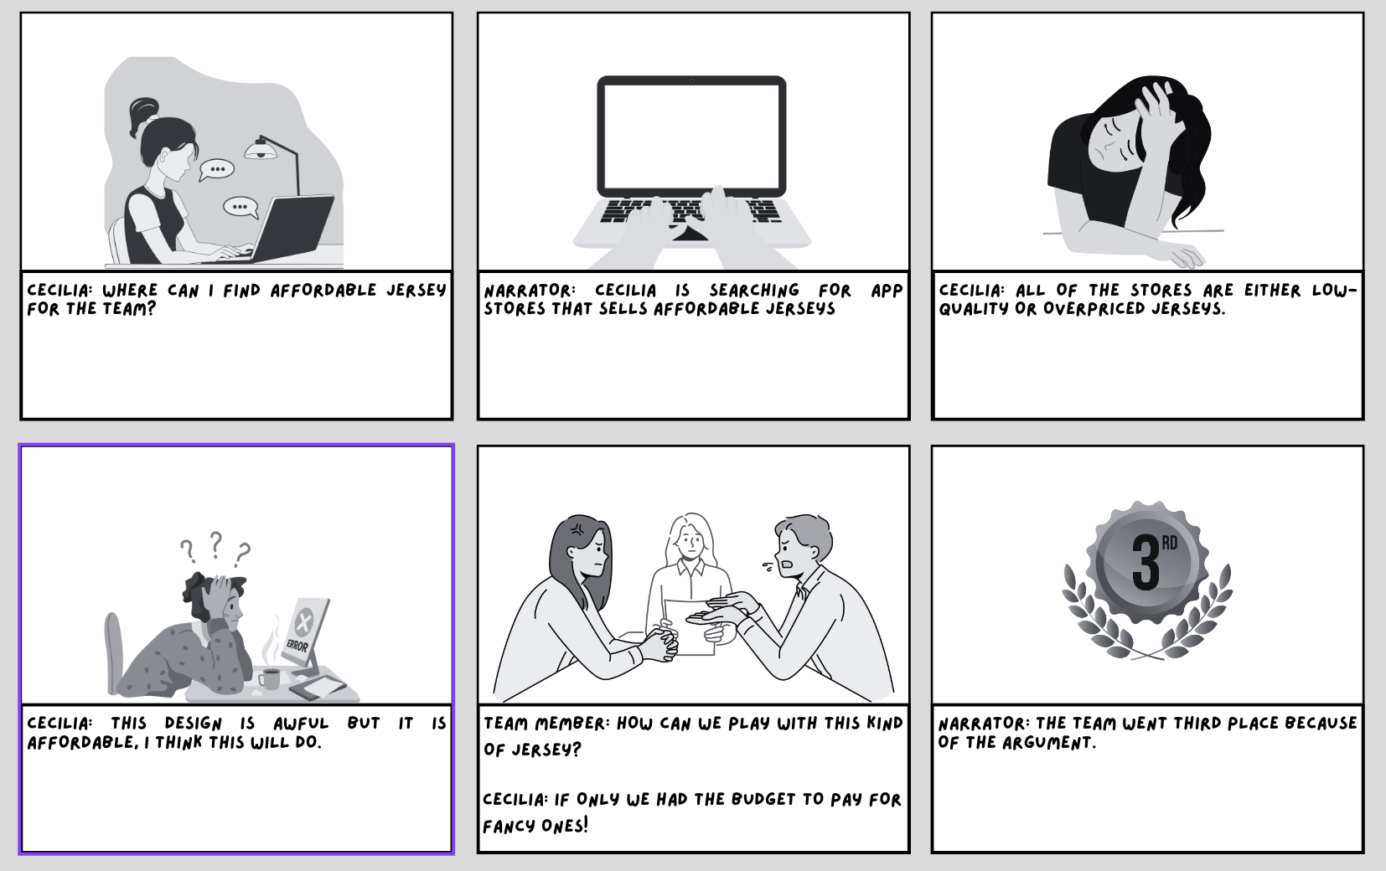

*Storyboard 3 – Cecilia*

***Prototype***

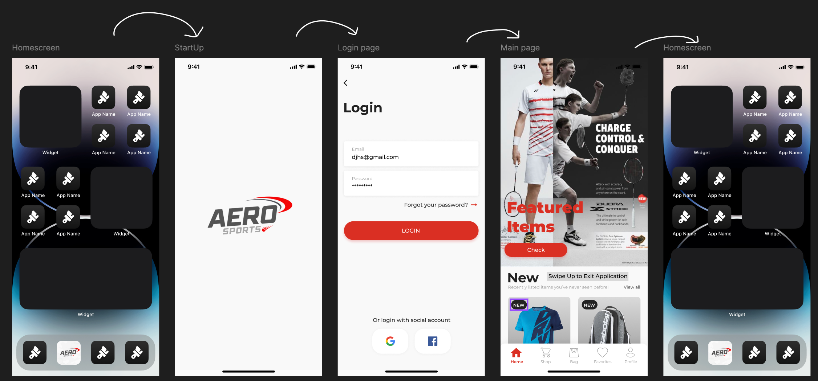

*Figure 1.1 Entering and Exiting Prototype*

The figure shows how the user can enter and exit the application.

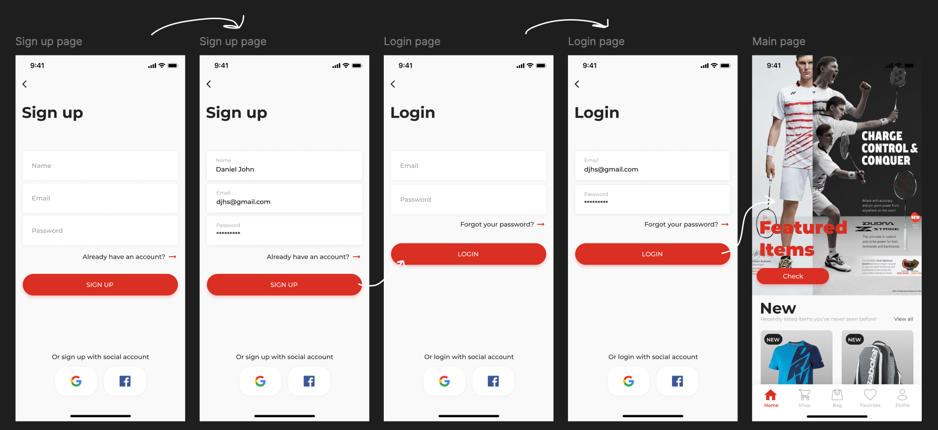

*Figure 1.2 Creating and Logging in an Account*

The figure illustrates the process of signing up for an account. If the user already has an account, they can click the arrow to proceed to log in using their account details or by using a social media account.

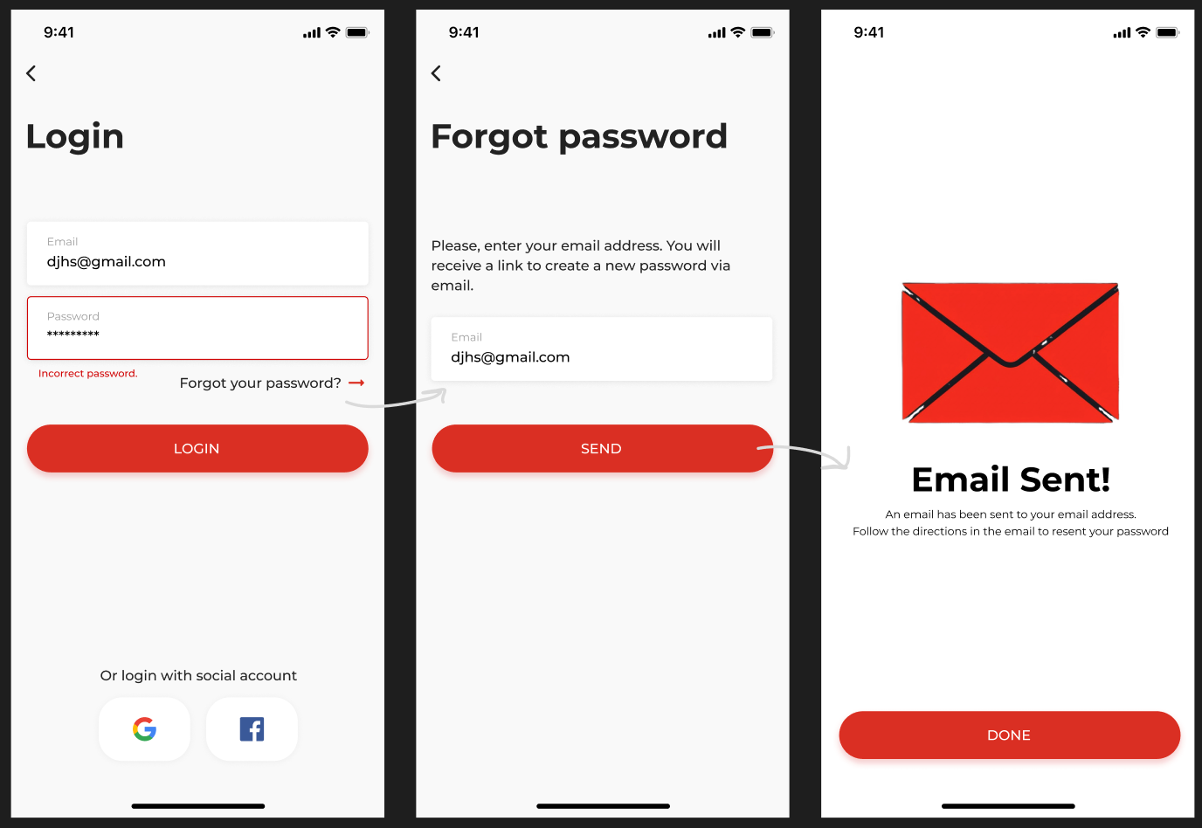

*Figure 1.3 Retrieving Forgotten Password*

The figure illustrates the process for users to reset their account password using the "forgot password" feature. A verification email will be sent to the associated account for confirmation.

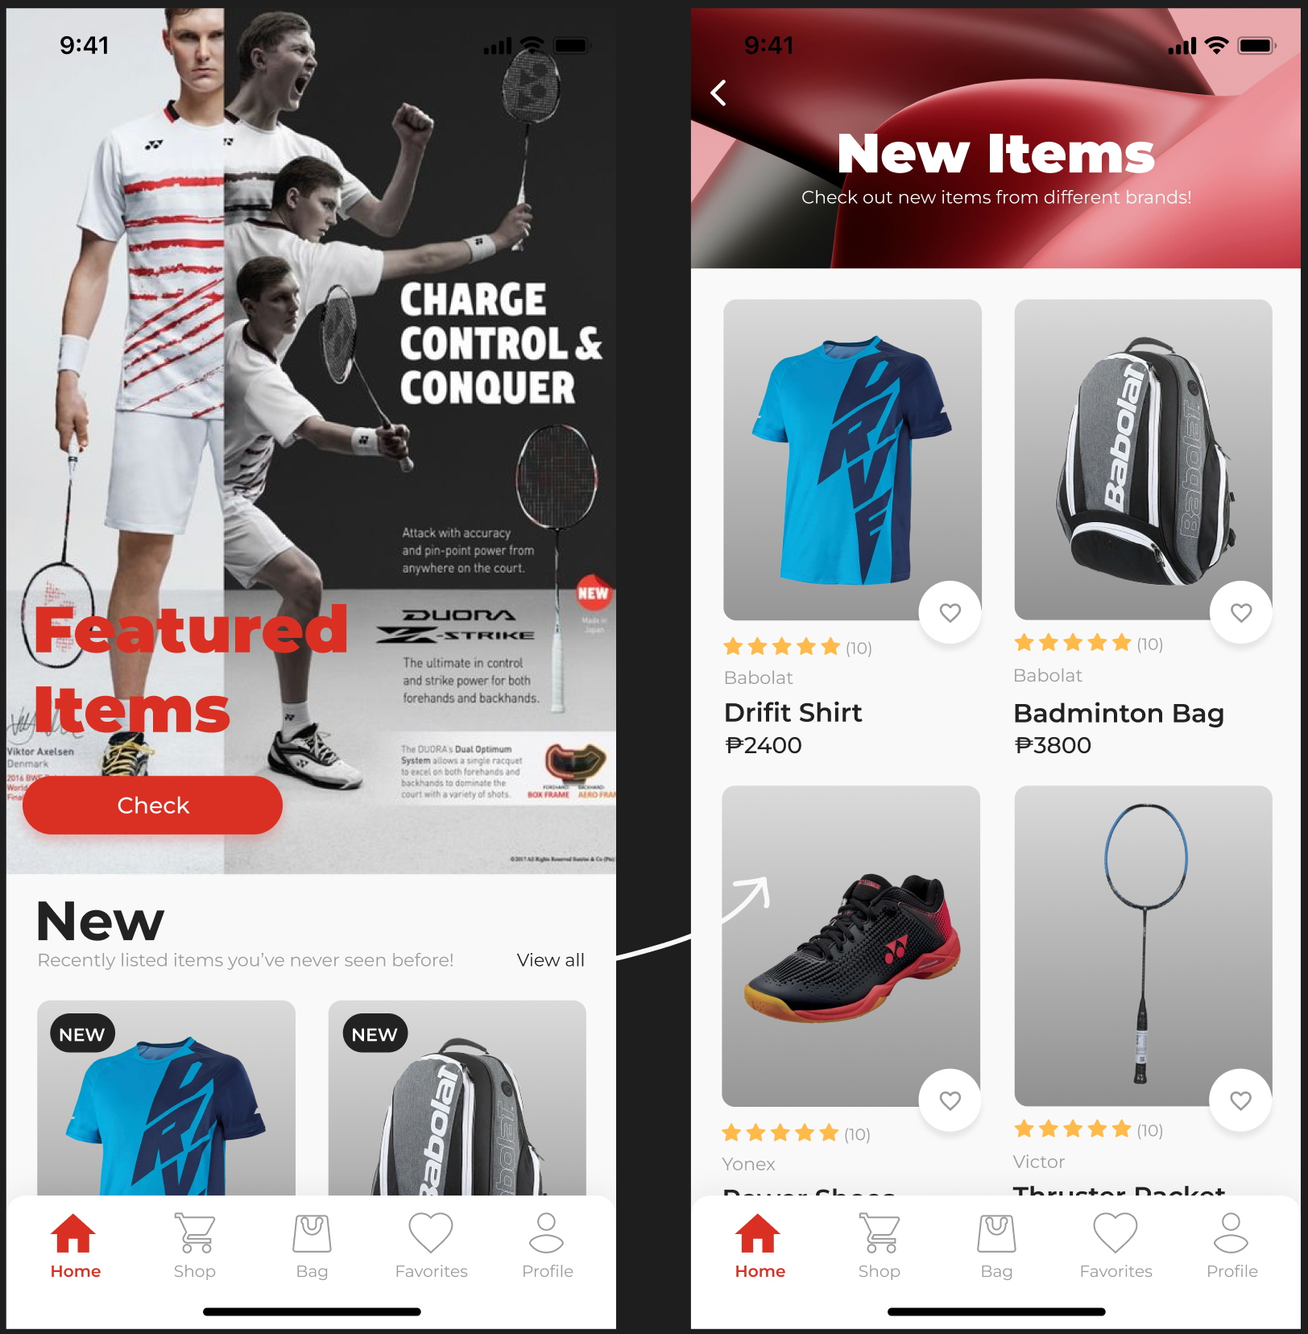

*Figure 1.4 Product Browsing – Featured*

The figure shows how the user can browse main menu of the featured products

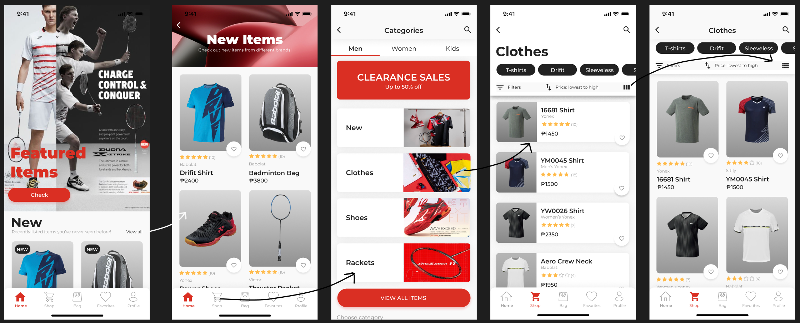

*Figure 1.4 Product Browsing – Categories*

The figure illustrates how users can browse products by categories. Users are redirected to the categories When they click on the shop logo in the navigation bar. Clicking on a category takes the user to a list of products within that category.

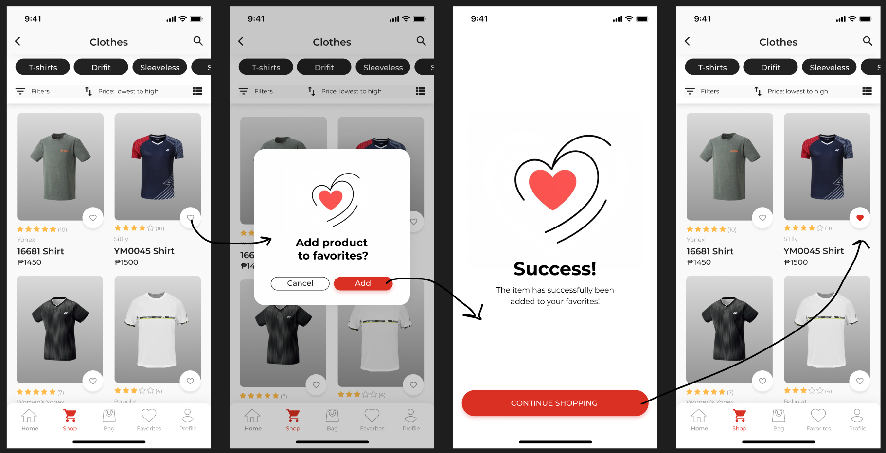

*Figure 1.4 Product Favorites*

The figure illustrates how users can browse products by categories. Users are redirected to the categories When they click on the shop logo in the navigation bar. Clicking on a category takes the user to a list of products within that category.

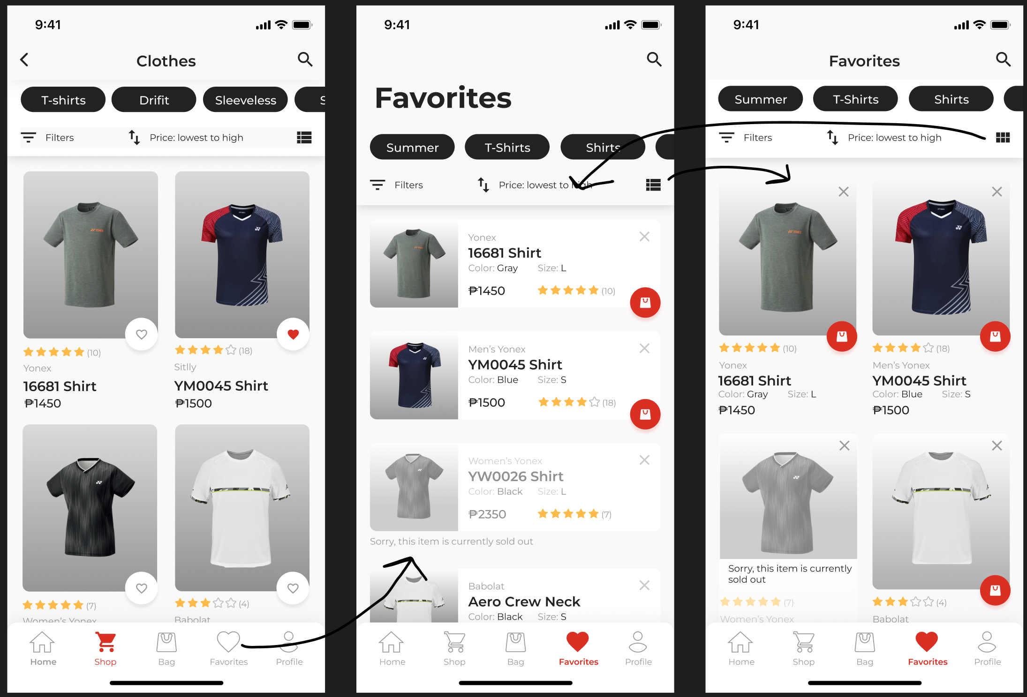

*Figure 1.6 Favorites Tab*

The figure shows how the user can navigate to the favorites tab. They can also delete certain products inside the favorites tab.

**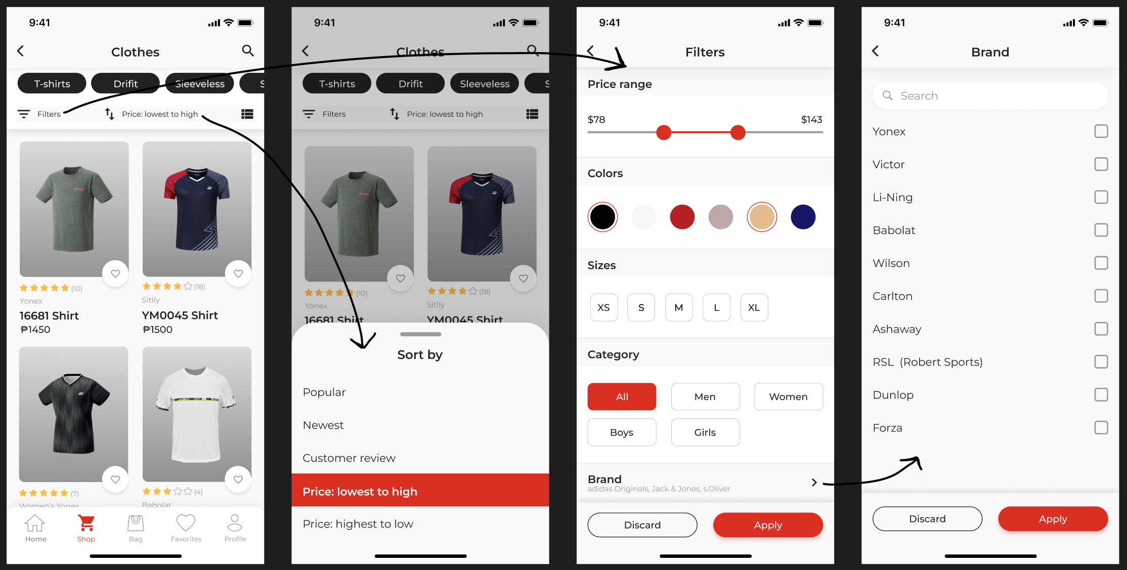***Figure 1.7 Sorting Products*

The figure illustrates how users can sort products based on their preferences. There are two methods: sorting and filtering, each with its own set of rules.

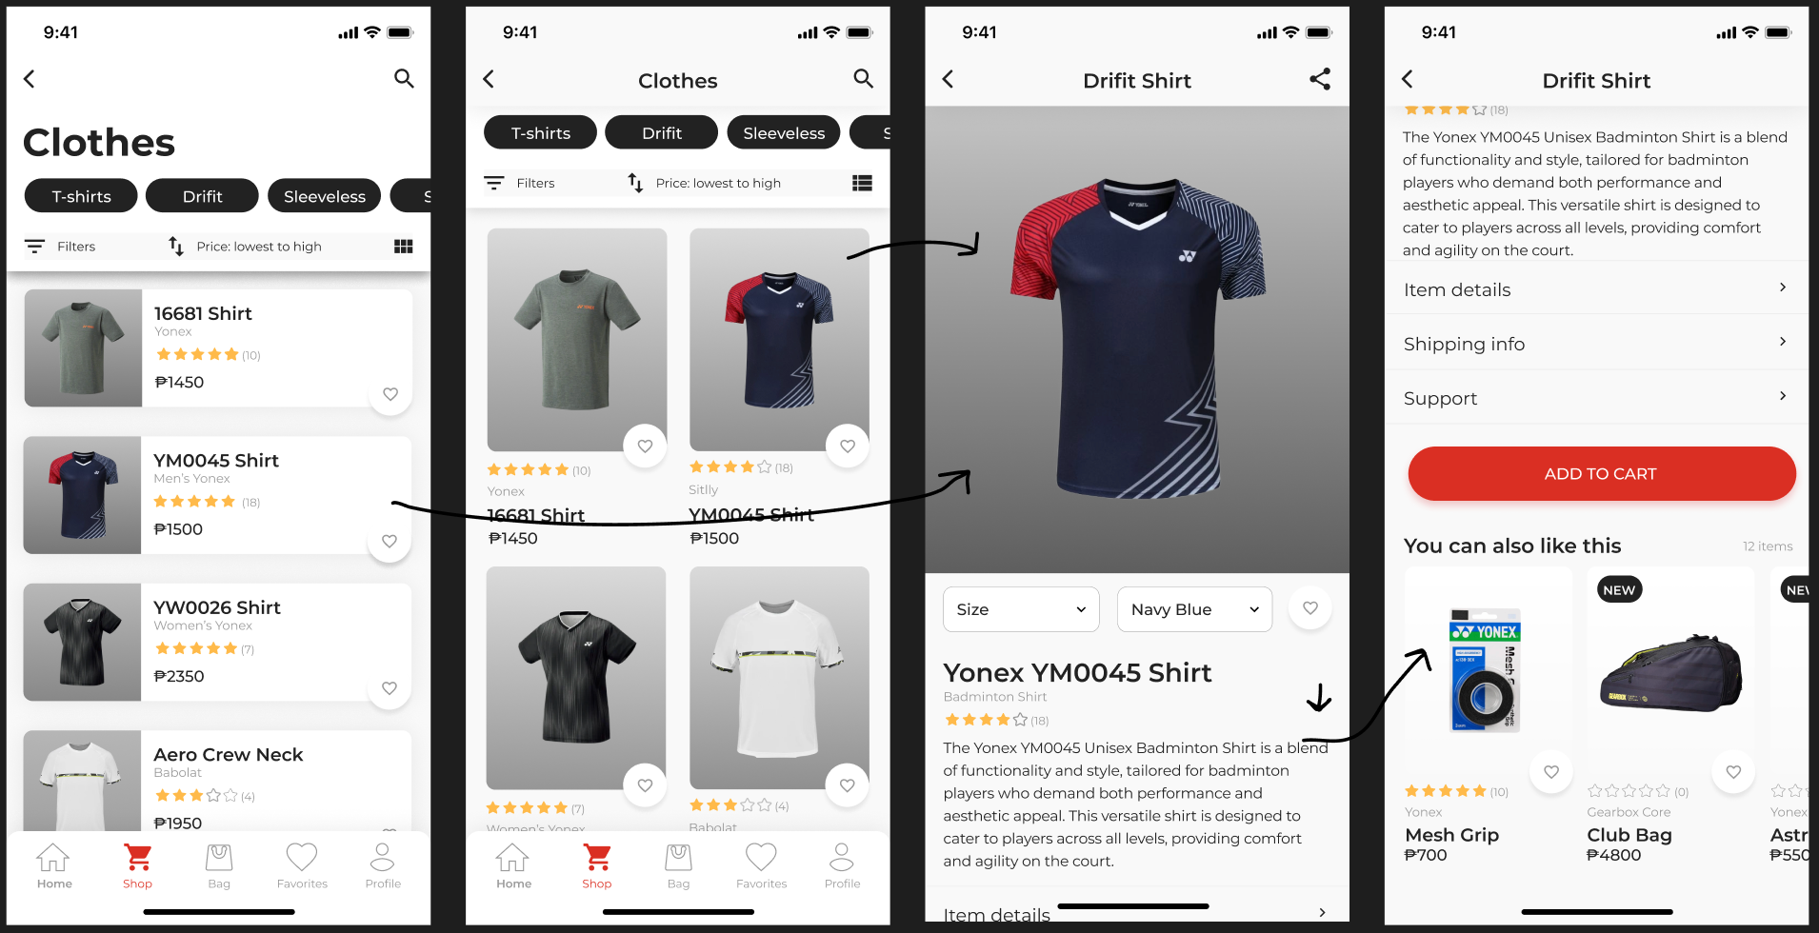

*Figure 1.8 Product Card*

The figure shows users how to navigate to a specific product card, allowing access to all necessary product information.

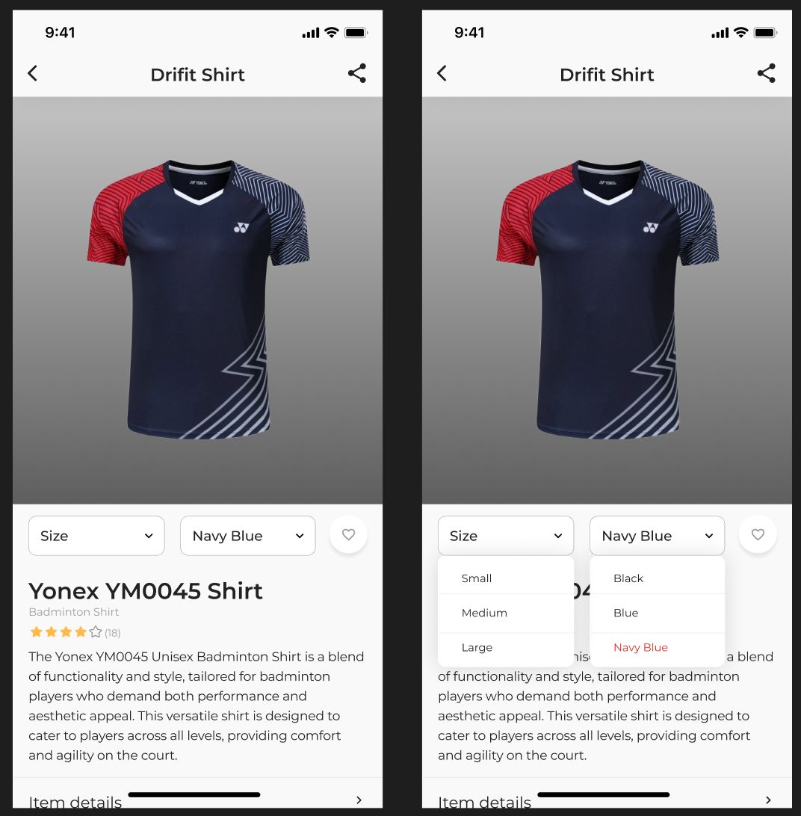

*Figure 1.9 Size/Color Navigation*

The figure illustrates how users can select available sizes or colors for a specific product they are viewing.



*Figure 1.10 Add to Cart*

The figure illustrates how users add a product to their shopping cart. It will ask for user confirmation before adding the product to the cart.

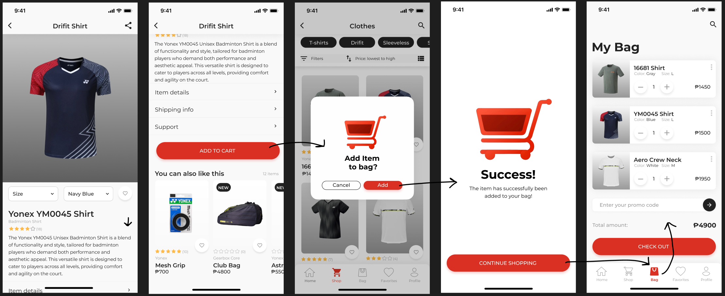

*Figure 1.11 Product Checkout*

The process for users to check out an order involves choosing a voucher, selecting a shipping address, payment method, and delivery method, seeing the order subtotal, and confirming the transaction.

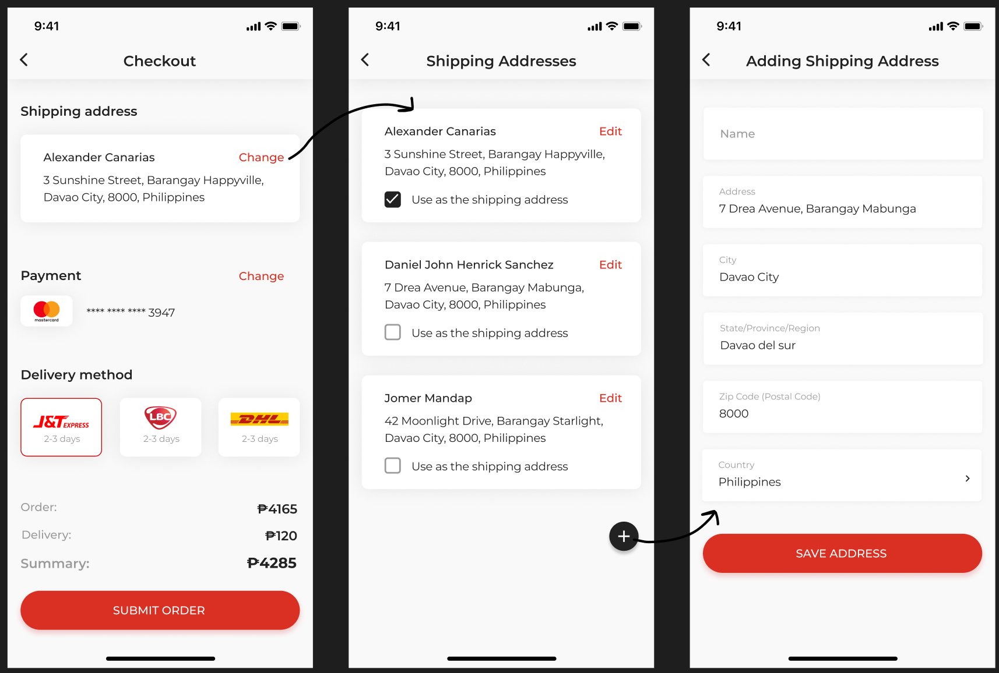

*Figure 1.12 Shipping Address*

This figure illustrates the process for creating, selecting, or updating a shipment address.

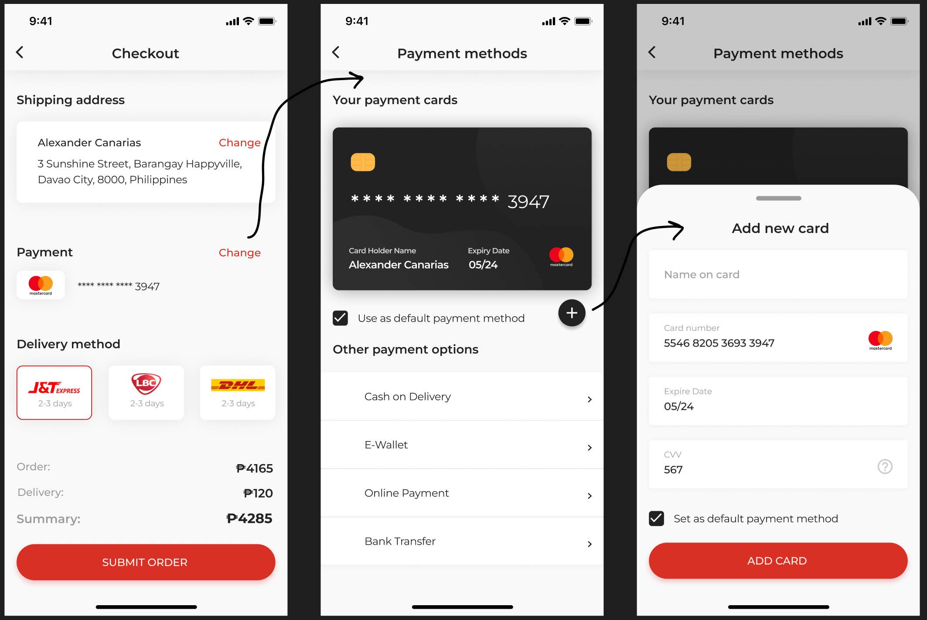

*Figure 1.13 Payment Methods*

The figure demonstrates how users can easily create or update their preferred payment method.

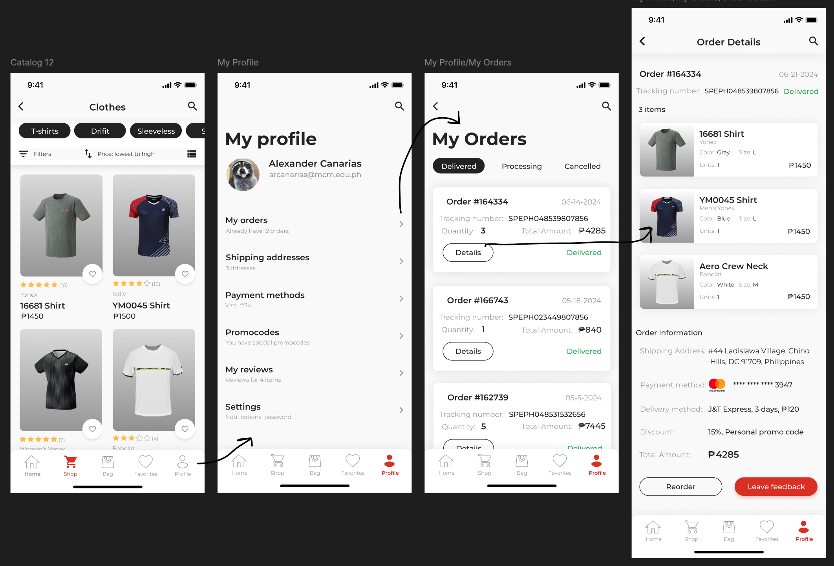

*Figure 1.14 Track Orders*

The figure illustrates the process for users to navigate and manage their orders, with the option to view specific order details.

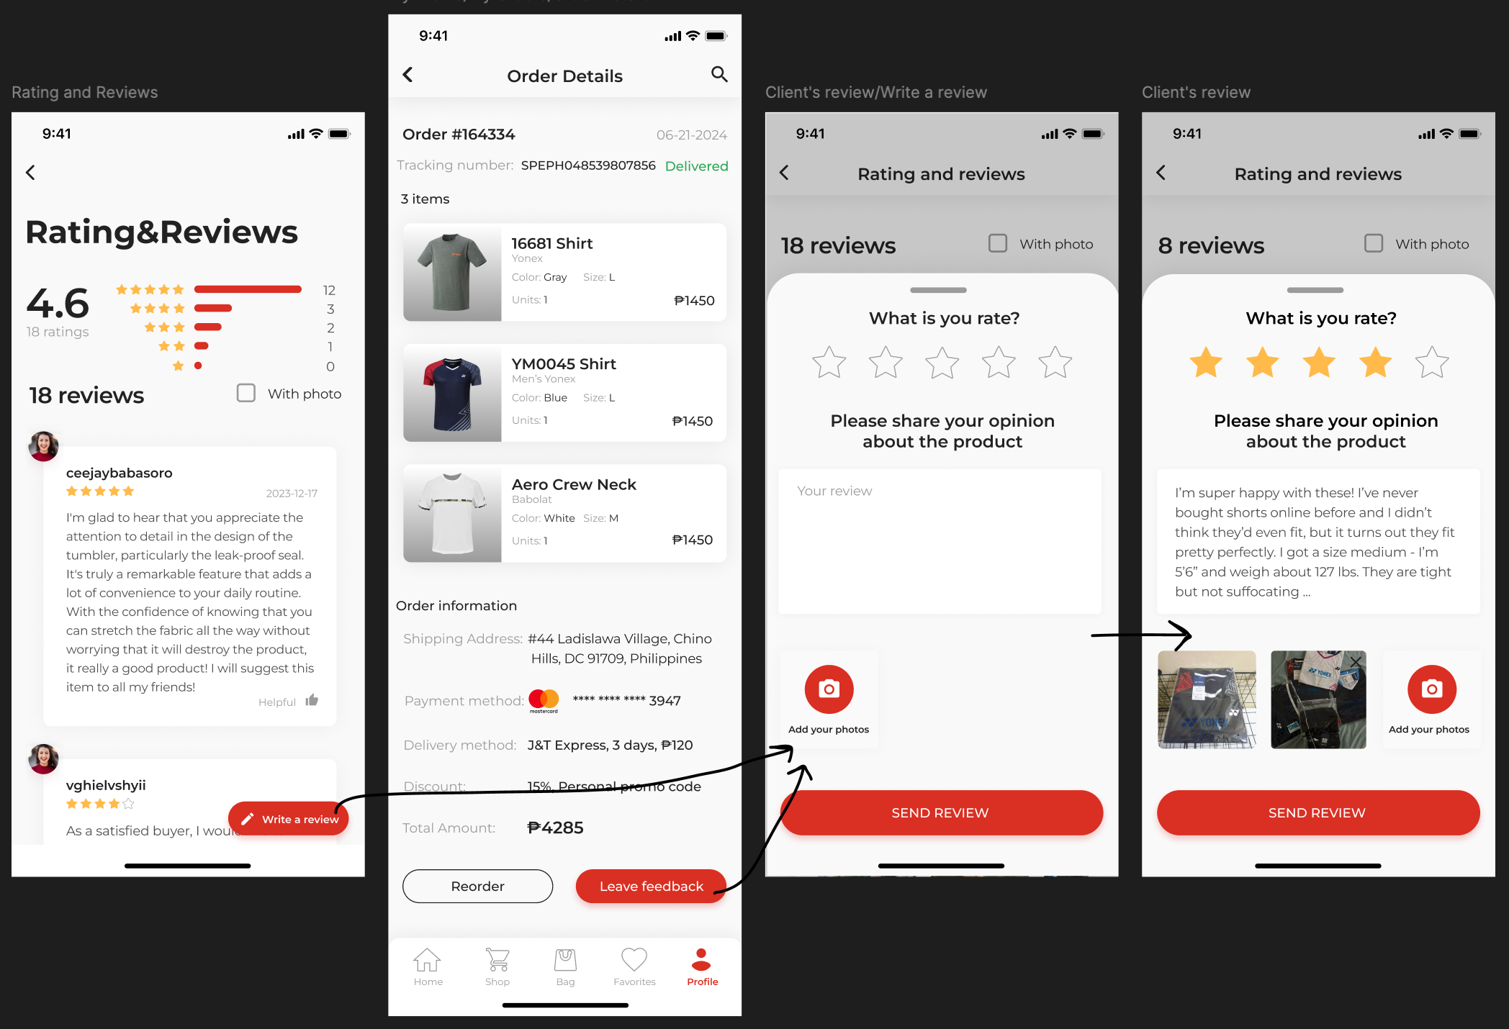

*Figure 1.15 Client Feedback*

The illustration demonstrates the process for users to provide feedback on a specific order they've placed.

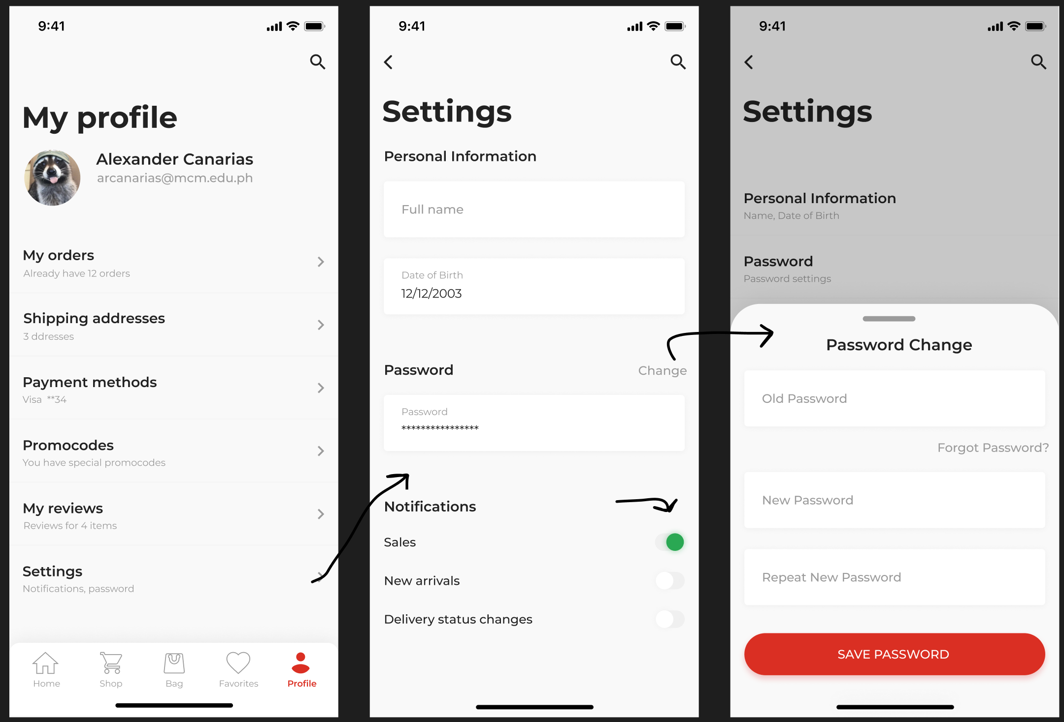

*Figure 1.16 Profile Settings*

The figure illustrates the system's application navigation, allowing users to modify notification settings and personal information, such as passwords.

1. **Evaluation of prototype**

Use heuristic evaluation with format given below. This is the criteria of how the design will be graded. **(Select the best design among 3 to 5 alternative designs within your team and evaluate)**

Evaluation Criteria (Based on the 10 heuristics of design evaluation)

|  |  |  |  |  |  |
| --- | --- | --- | --- | --- | --- |
| **Area of Evaluation** | **5** | **4** | **3** | **2** | **1** |
| 1. **Visibility of System Status**  * - The system design provides appropriate feedback like message prompts in response to user actions. * The message prompts are clear, visible and understandable. | / |  |  |  |  |
|  | / |  |  |  |
| 1. **Match between the system and the real world**   - Used words, phrases and concepts according to users’ language rather than system-oriented words and computer jargons. |  | / |  |  |  |
| 1. **User control and freedom**   - The system design provides ways of allowing users to easily “get in” and “get out” if they find themselves in unfamiliar parts of the system. | / |  |  |  |  |
| 1. **Consistency and Standards**  * - The colors, text, labels, buttons and other elements in the design are uniform from start to finish**.**   - Text and icons are not too small or too big.  **-** Menus and other features of the system are arranged and positioned in a consistent way. (For ex. If your website has navigation buttons on the top under the page title on one page, the users will automatically look there for the same features on other pages. | / |  |  |  |  |
| / |  |  |  |  |
| / |  |  |  |  |
| 1. **Error Prevention**   - The system design provides an automatic detection of errors and preventing them to occur in the first place.  - Idiot proofing mechanisms are applied |  | / |  |  |  |
|  | / |  |  |  |
| **F. Help users recognize, diagnose and recover from errors**  **-** Error messages and the terms used are recognizable, familiar and understandable for the users. |  | / |  |  |  |
| **G. Recognition rather than recall**  **-** Objects, icons, actions and options are visible for the user.  - Objects are labeled well with text and icons that can immediately be spotted by the user and matched with what they want to do. | / |  |  |  |  |
| **H. Flexibility and efficiency of use**  - The system design provides easy to navigate menus.  - the system does not make wasteful time of system resources. |  | / |  |  |  |
| 1. **Aesthetic and minimalist design**   **-**Graphics and animations used are not difficult to look at and does not clutter (mess) up the screen.  - Information provided is relevant and needed for the system design. | / |  |  |  |  |
| 1. **Help and Documentation**   **-**the system design provides information that can be easily searched and provides help in a set of concrete steps that can easily be followed. | / |  |  |  |  |

**Chapter III. Conclusion and Recommendation**

***Conclusion***

The AeroSports e-commerce application developed by LinTech addresses several key challenges faced by badminton enthusiasts, event organizers, retail partners, and other stakeholders within the badminton community. By centralizing a wide range of badminton products into a single, user-friendly platform, AeroSports significantly enhances the shopping experience for players and fans alike. The app’s features, such as comprehensive product descriptions, user reviews, comparison tools, and efficient procurement processes, cater specifically to the needs of the badminton community, which have been previously underserved by traditional retail channels.

Our project illustrates the critical role of integrating advanced functionalities like multilingual support, offline mode, and robust inventory management in enhancing user engagement and satisfaction. The insights gained from this project emphasize the importance of applying Human-Computer Interaction (HCI) principles to create intuitive and accessible interfaces that meet the unique demands of niche markets.

***Recommendation***

To further improve the AeroSports application and maximize its impact, we propose the following recommendations:

1. *Multilingual Support Integration*

* Implementing multiple language options will significantly enhance the app's accessibility for non-English speaking users, thereby expanding its global reach. Localization should encompass not only text translation but also cultural nuances to provide a seamless user experience across different regions.

1. *Offline Mode Implementation*

* Introducing an offline mode will allow users to browse products and access their favorites without an active internet connection. This feature is particularly beneficial for users in regions with unreliable connectivity and those who prefer not to use mobile data.

1. *Enhanced Inventory Management*

* Improving inventory management systems will ensure better product availability and reduce user frustration caused by stock shortages. Features such as real-time stock updates, waitlists, and back-in-stock notifications will keep users informed and engaged.

1. *User-Centric Design Improvements*

* Continuously refine the user interface to prioritize ease of navigation and accessibility, making it intuitive for users of all skill levels. Incorporate user feedback to address pain points and enhance overall user experience.

1. *Expanded Social Features*

* Enhance the community aspect of the app by integrating social features like forums, user groups, and event announcements. These features will foster a stronger sense of community among badminton enthusiasts and provide additional value to users.

1. *Continuous Feedback Integration*

* Establish a robust feedback loop to gather user insights and continuously improve the app's functionality. Regular updates based on user feedback will ensure that the app remains relevant and meets the evolving needs of its user base.

By implementing these recommendations, the AeroSports app will not only meet the current demands of badminton enthusiasts but also position itself as a leading platform in the badminton e-commerce market, ensuring long-term success and user satisfaction.